FUTURE CONSUMER 2026



FUTURE

CONSUMER

2026

Future Consumer 2026

WGSN ensures the world’s leading brands create the exact products that tomorrow’s consumers will buy

EXECUTIVE SUMMARY

#### Our Future Consumer forecast identifies the four shopper profiles you need to know for 2026

The Gleamers



FUTURE

CONSUMER

2026

Burnout has left this group yearning for a simpler life. From rural revitalisation to chosen families, they are redefining what community, care and fulfilment look like.

The Autonomists

These consumers move to the beat of their own drum, setting their own rules and values. They are finding purpose by rebelling against societal norms and embracing supportive collectives.

The Impartialists

Amid a crisis of disinformation, these level- headed consumers are seeking facts over fiction and unvarnished transparency over slick storytelling. Honest messaging and simplified sales will win their trust.

The Synergists

These curious consumers are on a mission to make our fast-changing world better for all – both online and in real life – by advocating for cultural contraflows and human-tech symbiosis.



FUTURE

CONSUMER

2026

# The Gleamers

Let’s meet The Gleamers,

who are redefining happiness one ‘minorstone’ at a time

Squeezed between rising living costs and the pressures of hustle culture, The Gleamers are turning their back on traditional life milestones to celebrate smaller pleasures, community support

networks and more achievable ‘minorstones’.

The Gleamers are finding their light in dark times by opting out of corporate optimisation and redefining what success, happiness and community mean on a more personal and sustainable scale. These pragmatic optimists are sceptical about societal expectations of attainment, preferring to celebrate the small wins and silver linings – the glimmers of joy – that make everyday life better. They are acutely focused on care, both for themselves and others, and ‘found families’ (chosen kin rather than



FUTURE

CONSUMER

2026

kin defined by biology). They are also pioneering the great migration that WGSN has been tracking since

2021, trading in urban lifestyles for more affordable suburban and rural locations, and revitalising neighbourhoods along the way.

**What they need**

The Gleamers need uplifting products, services and experiences that offer small but significant improvements

to everyday life. As people who think outside of societal expectations, they will expect brands to design for their life stage rather than their biological age, and they will be drawn to anything that nurtures care, community and happiness in tangible and achievable ways.



FUTURE

CONSUMER

2026

# Strategies

Four strategies for success with The Gleamers

##### Be a beacon of care

2

1

Celebrate small accomplishments

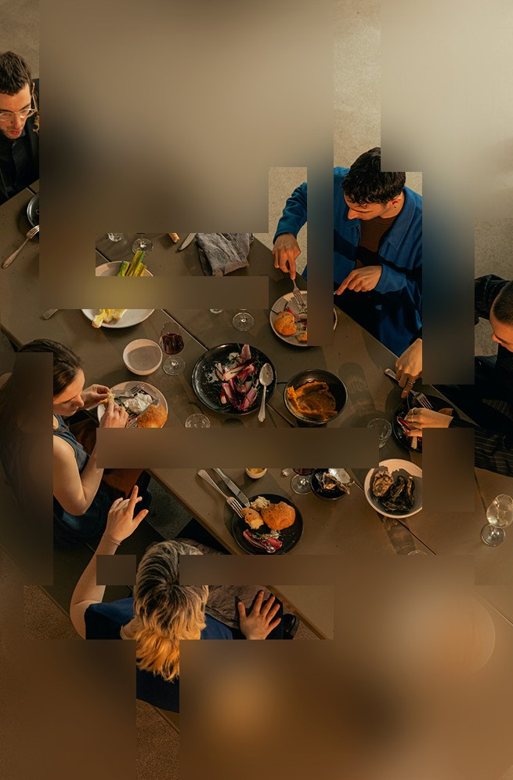

FUTURE

CONSUMER

2026

Identify the mini milestones – AKA minorstones – that will resonate most with your consumers, whether it be pet anniversaries, a new car, or a healthy lifestyle change, and create products and services that facilitate and celebrate these. Supporting people through small wins is one

of the most impactful ways to gain their trust and long-term loyalty.

The Gleamers are pushing back against burnout and bounce-back culture (the expectation to ‘snap back’ after major life changes such as pregnancy or illness), and they will expect the same from you.

Make care – for self, others and the planet – your raison d’être, and explore how your business can nurture kinder and healthier habits, whether by enabling better rest, more mindful snacking or more sustainable consumption.



FUTURE

CONSUMER

2026

##### Invest in the rural revival

3

The lure of the major metropolis is waning as people search for more affordable and sustainable lifestyles outside big cities. The Gleamers are pioneering this shift, so it’s essential to meet them where they are. This could take the form of setting up shop in new locations or creating products and services that help people unplug and escape the city, even if only for short breaks.

##### Facilitate third spaces

Third spaces are those outside the usual social environments of home, job and school,

4

and they will have a unique appeal for Gleamers, who see community and connection as intrinsic to their happiness

There are many more consumer insights and strategies on wgsn.com.

[Contact us](https://www.wgsn.com/en/future-consumer-2026-demo?utm_campaign=future-consumer-2026&utm_medium=referral&utm_source=whitepaper&utm_content=demo-report&utm_term=noterm) to become

a member

and wellbeing. Align your brand with these spaces – whether

it be an exercise event in a park or a learning event in your store – to create memorable experiences that go light on the selling and big on the positive takeaways.

# What’s driving The Gleamers?



FUTURE

CONSUMER

2026

Joy-seeking

49%

Percentage of people who would be more likely to purchase from a brand that brings them a sense of joy



The Gleamers in numbers

**Ethical consumption**

+6YoY incre2ase in socia%l media

buzz around the topic of ethical chocolate

– WGSN TrendCurve

FUTURE

CONSUMER

2026

– VML

Banishing burnout

42%

Percentage of workers in Japan,

Australia, the US, the UK, France and Germany who say they are burned out

– Future Forum Pulse survey

Therapeutic



The Gleamers in numbers

**Prioritising personal care**

Penet2ration of ha6ir health as%a topic of conversation among beauty influencers on social media

– WGSN TrendCurve

FUTURE

CONSUMER

2026

**hobbies**

74.5

$ bn

Projected size of the global art and craft

market in 2031, up from $44.1bn in 2021

– Business Research Insights

Mental health mindfulness

12bn

Number of working days lost every year globally to depression and anxiety

– World Health Organization

#### Profile evolution

2026

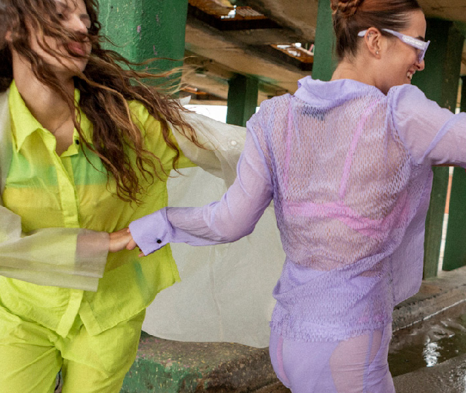

FUTURE

CONSUMER

2026

###### The Memory Makers

2024

The Memory Makers are giving up the quest for perfection to focus on the pursuit of being present, and they are decluttering anything that gets in their way.

###### The Time Keepers

The Time Keepers are creating a richer life through daily rituals and meaningful experiences, and they are giving their attention to things that add value to their world.

2025

###### The Gleamers

In a world that feels like it’s getting bigger, faster and more pressured, The Gleamers

are scaling back on societal expectations to scale up their daily joy and fulfilment.

**What’s next?**



The Autonomists

The Impartialists

The Synergists

[Request access](https://www.wgsn.com/en/future-consumer-2026-demo?utm_campaign=future-consumer-2026&utm_medium=referral&utm_source=whitepaper&utm_content=demo-report&utm_term=noterm) to the full 2026 Forecast

FUTURE

CONSUMER

2026

## Discover the sentiments and the other Future Consumer profiles that will drive change in 2026

The Gleamers

Viewed

Unlock subscriber content

Unlock subscriber content

Unlock subscriber content

## WGSN is the world’s leading trend forecaster, trusted by the world’s biggest and most innovative brands



FUTURE

CONSUMER

2026

**About WGSN**



FUTURE

CONSUMER

2026

### Our methodology

WGSN provides a holistic view of global trends through our unique STEPIC methodology, which tracks new developments across six pillars: Society, Technology, the Environment, Politics, Industry and Creativity.

To ensure unrivalled accuracy, we combine these qualitative inputs with WGSN TrendCurve+ – our predictive analytics product combining data sources from social media, search terms, e-commerce data, catwalk shows and consumer sentiments – to tell you which trends to invest in, how deeply and when.

Observe

STEPIC

1

Society TechnoLogy Environment PoLitics Industry Creativity

WGSN Proprietary Data WGSN Experts

Synthesise

Aesthetic Connection

AnaLytics and Data ModeLLing

CriticaL Debate

Forecast

Consumer Insight LifestyLes Product Design

3

Continuous Monitoring

Focus

Trading

4

5

Re-evaluate



FUTURE

CONSUMER

2026

**About WGSN**

### Our foresight helps businesses understand the changes they need to act on now so they can make the best products and services for tomorrow.

Our expertise covers every product and service that touches people’s daily lives, from the clothes they wear to the skincare they use, the food they eat, the technology they connect with and the home products they surround themselves with.

[Contact us](https://www.wgsn.com/en/future-consumer-2026-demo?utm_campaign=future-consumer-2026&utm_medium=referral&utm_source=whitepaper&utm_content=demo-report&utm_term=noterm)

to see how we can future-proof your business today

Wherever your consumer is, we are there, three steps ahead.

With experts in every corner of the world, WGSN offers a truly global perspective of the forces that will shape our future, and our Mindset consultancy business provides additional bespoke services.